Escape Rooms Build Better Researchers
Shauna Edson, University of Wisconsin - Parkside

Abstract
With the shift to learner-centered education, academic libraries have opportunities to design programming that reflects the contextual active learning occurring in the classroom. The University of Wisconsin - Parkside Library designed a flexible research game for patrons of different backgrounds and abilities using the Breakout EDU box. This game introduces different age groups to the library and the skills needed to be a successful researcher in a fun hands-on way. Utilizing constructivist learning techniques, such as modeling, coaching, scaffolding, exploration and articulation, the game requires participants to practice creativity and collaboration, two very important research skills. Overall, the experiences of both library moderators and participants in this game have important implications for classroom research instruction.
Keywords: active learning, gaming, gamification, constructivist learning theory

With the shift to learner-centered education, academic libraries have opportunities to design programming that reflects the contextual active learning occurring in the classroom. University of Wisconsin - Parkside Library designed a flexible research game for patrons of different backgrounds and abilities using the Breakout EDU box. This game introduces different age groups to the library and the skills needed to be a successful researcher in a fun hands-on way. Utilizing constructivist learning techniques, such as modeling, coaching, scaffolding, exploration and articulation, the game requires participants to practice creativity and collaboration, two very important research skills. Overall, the experiences of both library moderators and participants in this game have important implications for classroom research instruction.
What Is Breakout EDU?
Breakout EDU boxes have been popular in K-12 classrooms in recent years because they offer a flexible active-learning experience for a range of ages, number of participants and diversity in abilities. Like popular escape room games, Breakout EDU boxes require participants to work together to solve clues and unlock number, letter, directional and key locks. The game often has a unifying story that creates context for the clues and allows educators to capitalize on students’ familiarity with solving story problems (Jonassen, 2003, p. 268). It is flexible enough that it can be used in different subject areas. Rather than break out of a room at the end, as in an escape room, participants find a final prize locked in the large Breakout EDU. This game moves the instructor from expert to collaborator, an important mark of active learning design (García-Cabrero et al., 2018, p. 825). It engages students by tying in contextual real-world experiences, active learning, and research skills.
Our Library’s Escape Rooms
Libraries are often looking for innovative ways to promote resources and services to busy patrons. Study rooms are regularly updated and refreshed in UWP Library to make them more attractive to campus users. New furniture and technology were added to a study room and the Breakout EDU box was used to market the new room to campus in a unique way. The Purple Escape Room Game (https://tinyurl.com/y5ww93nd) was advertised throughout the month of February 2019 to capitalize on the beginning of spring semester to provide a fun indoor activity during the cold weather. Our marketing activities were designed to target everyone on campus (faculty, staff and students) and included fliers, posters, emails to student organizations, and social media posts. Ultimately, two groups played the game.
Our second escape room program coincided with campus participation in Bring Our Daughters and Sons to Work Day (https://www.daughtersandsonstowork.org/), in which many institutions and companies participate nationwide every year. A group of campus organizers invited the children of employees to campus so they could learn about their parents’ work. In the library, 40 children, ages 7 to 12, played the Bring Our Daughters and Sons to Work Day Escape Room in two 90-minute sessions (https://tinyurl.com/y3p73jsw). The library’s goal was to introduce the children to the library and the skills needed to be a successful researcher in a fun flexible way.
Clues for both games encouraged participants to explore some of the features in the room, as well as familiarize them with current library resources and services. Websites, books, DVDs and CDs, as well as the computer and projector, were used to encourage active learning. The variety of physical and digital clues, along with the social aspect of the game, were combined to design a game that aimed to achieve a deeper level of learning and tap into intrinsic motivation in our participants (Garcia-Cabrera, 1991, p. 830). One example of the interplay between physical, digital and social elements of the game is the YouTube URL cards (see Figure 1). This clue is the shortened and printed out URL to a YouTube video created and uploaded by the library. Sections of the URL were cut into pieces and hidden around the room. Participants needed to put the pieces together (physical), realize it was a URL (digital), try out different sequences of the URL (digital and social), watch the video (digital) and finally, pick out the word clue to enter into one of the locks (physical and social). This required technical skills, collaboration and perseverance.
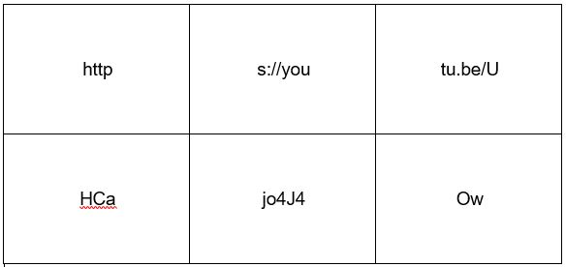
Figure 1: YouTube URL cards
For the children’s version, some of the game clues changed to resonate with a younger audience. For example, DVDs and CDs were used as clues in both games to promote our physical resources. Knowing that Taylor Swift is very popular and would be recognized by different ages, a variety of Taylor Swift CDs and printed-out lyrics from one of her songs were used as clues (see Figure 2). The lyrics had the clue hidden in them, so participants needed to figure out that the CDs were red herrings (i.e., a clue intended to mislead), realize that the lyrics had the clue, and enter the clue in the correct lock.
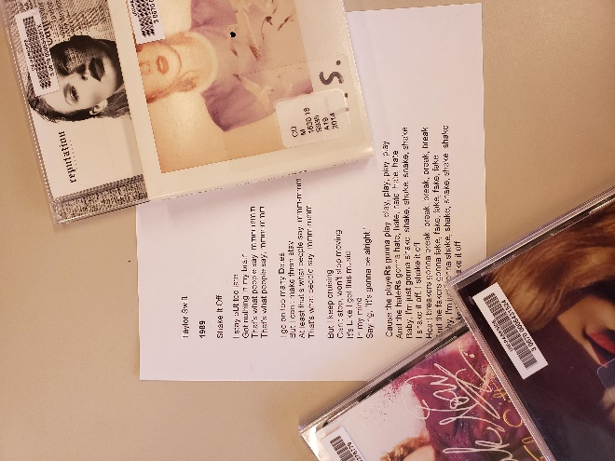
Figure 2: Taylor Swift CDs and Printed-Out Lyrics
Building Context
According to Gupta (2011), we know that learners build new knowledge from what they already know, so it was important to prepare participants for success with the game by creating context and tying in real-world experiences (p. 30). Surprisingly, the adult participants did not have any experience playing an escape room, so context was created by showing them a short video on YouTube with people playing an escape room game. In the video, the participant read clues, found patterns and tried out potential answers. This form of modeling or allowing participants to watch while an expert performs a task, gave the adults a framework for their own escape room activities and strategies moving forward (Collins, 2006, p.50). Moderators also provided an “Escape Room Tips” poster with helpful suggestions and ideas on how to play the game (see Figure 3). One of the suggestions was to look at the locks before exploring the clues. A participant might narrow down the information they are looking for if they take the time to inspect the types of locks involved. The poster was one of the ways scaffolding, which refers to the supports the moderator provides, was used to provide participants with some direction and guidance without requiring hands-on intervention form the moderator (Collins, 2006, p. 51).
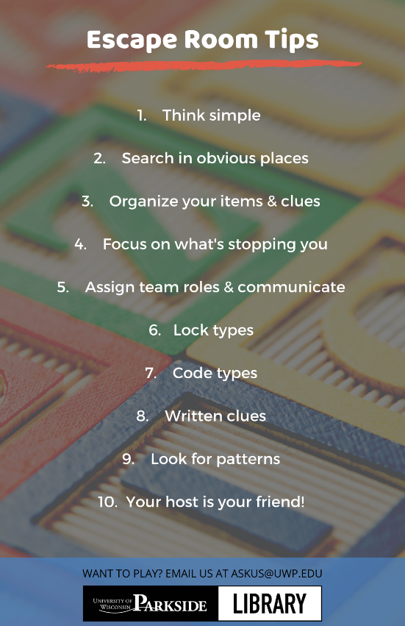
Figure 3. “Escape Room Tips” poster. Adapted from “Beat any escape room. 10 proven tricks and tips” by Marc Rober. Published on YouTube August 29, 2018. Retrieved from https://youtu.be/zwgaTYOx0RI.
Among the groups of children, there were several who were happy to share their escape room experiences with their peers. This moved the child into the role of expert and shifted the library moderator to the role of coach. The role of coach involved providing feedback and guidance to learners throughout the game so they could maximize their active learning experiences (García-Cabrero, et al., 2018, p. 825). Reading the “Escape Room Tips” poster out loud before the game provided the participants with even more context for the game and served to assist the library moderators in coaching the children through some of the harder clues. Moderators could refer to the poster without getting too specific and giving away the clue.
Taking Advantage of Constructivist Learning
By asking participants to apply previous knowledge, try out new ideas, and discard or integrate those lessons, the escape room game is an excellent example of constructivist learning. According to Gupta (2011), constructivist learning “sees learning as a dynamic process in which a learner constructs new ideas or concepts on their current/past knowledge and in response to the instructional situation” (p. 30). Constructivist learning places the learner in the important position of actively participating in their educational experiences. Encouraging constructivist learning strategies, such as question-asking, allowed some participants to learn more about the rules of the game, while others could quickly progress into solving clues (Bada, 2015, p. 68). The first adult group indicated that they did not have any experience with escape rooms, so the librarians moderating the game coached them by suggesting questions they could ask and providing feedback when they got stuck (Urbani, et al., 2017, p. 32). Despite this coaching, the first adult group neglected to ask questions and quickly became discouraged. In contrast, the second adult group took advantage of asking for guidance and were able to break open the box!
The children did not ask as many questions, preferring to try things, fail or succeed, and move on. Library moderators did not wait for them to ask questions and instead, actively coached the children through hints, reminders and new tasks (Collins, 2006, p. 51). For example, when one group of children fixated on the red herring Taylor Swift CDs for several minutes and ignored the print-out of the lyrics, the library moderator reminded them to make sure they explored all of the clues before spending a lot of time on one clue. When one of the children picked up the lyrics, the moderator offered encouragement to continue to explore that clue and the rest of the children quickly got the hint.
Highlighting Research Skills
Just as researchers need to approach scholarship with creativity and be open to collaboration, escape room participants had to work together to come up with original ideas and approaches for solving clues. Creativity in research is “the ability to develop, choose, and integrate novel, unconventional, and innovative approaches” (Urbani, et al., 2017, p. 30). In order to give participants room to generate creative ideas towards the game challenges, library moderators added another constructivist learning technique called exploration, in addition to modeling and coaching. According to Collins (2006), exploration occurs when the library moderators invite participants to pose and solve their own problems (p. 50). Moderators tried to strike a balance between coaching and exploration, and in the end, adults did not come up with as many original ideas to solve the clues compared with the children. For example, one of the clues was an illustration of several trashcans from one of the books (see Figure 4). It was meant to lead them to the trashcan in the room and to the key hidden underneath. The adults were intent on looking for that page in the book and were stumped as to what to do next, while the children looked around the room and ran to the garbage can to test out their idea. Coaching adults to look for patterns, as was suggested on the “Escape Room Tips” poster, seemed to help redirect their attention to potential new approaches to solving the clue.

Figure 4. Moss, J., & Gross, Michael. (1977). Oscar's book (Little Golden Books). Racine, Wis.: Western Pub.
Collaboration in research is “the ability to work productively and equitably while valuing others in diverse educational settings (Urbani, et al., 2017, p. 30).” Library moderators used articulation, another constructivist learning strategy, to encourage collaboration throughout the game. Collins (2006) describes articulation as when the moderator encourages participants to verbalize their knowledge and thinking (p. 50). For example, when looking at the Wikipedia clue, one adult participant wondered aloud whether the numbers in the Wikipedia article could be the clue for the numerical lock. The group moved away from this suggestion and tried a few more ideas. The library moderator directed them back to the numerical idea by asking the individual to repeat their idea. This encouraged the group to redirect their energy and focus on the numbers. Articulating their idea seemed to draw others in to try and help as well. For example, when the children were asked to state their idea out-loud, others who had worked on that clue previously and moved on, would come back and try to help now that they had a new direction. This game clearly creates a valuable opportunity to learn to exchange ideas and negotiate with others to achieve a common goal (Bada, 2015, p. 68).
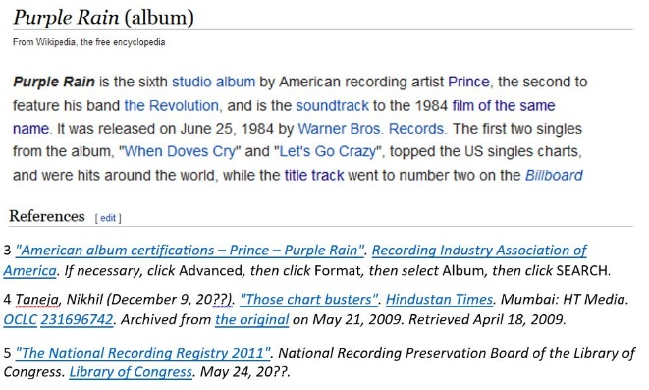
Figure 5: Wikipedia Clue. Adapted from “Purple Rain (album)” Wikipedia entry. Last edited October 21, 2019. Retrieved from https://en.wikipedia.org/wiki/Purple_Rain_(album)
Conclusion
Creating context proved to be a very important way to introduce the game to both adults and children. Both groups benefited from watching “experts” play the game so they would have a strategy for how to move forward. Library moderators did not provide as much coaching and scaffolding to the adult groups, thinking they would prefer the freedom of exploration. In reality, all groups benefited from more context. Although the game is flexible enough that moderators were able to provide coaching where context was lacking, more scaffolding may have decreased the cognitive load required to solve the clues. According to Mayer, Moreno, Boire, and Vagge (1999), when learning is not well-designed, students are required to absorb large amounts of information on their own. The cognitive load becomes too high without supports and they will struggle and be less successful (p. 642). The adults seemed to suffer the most at the lack of the scaffolding in some clues and were less successful than the children in generating creative ideas and approaches. Most successful escape room and Breakout EDU games provide a scenario or story to create context for the clues. Adding a story to future library escape rooms may help create more authentic research scenarios, in which participants would interact with library resources and services in a realistic way. This may be one step towards providing the background, motivation and context that make a successful escape room experience.
Creating context for the escape room game could easily inform research instruction in the classroom. Modeling should be used in the classroom to demonstrate using research tools so students can learn from an expert. Scaffolding through examples, instructions, case studies, and low stakes activities should be more widely integrated into research instruction to make the most of active learning. Finally, coaching in the classroom may take the form of feedback, encouragement, or listening, and can help students during their independent research explorations.
The constructivist learning techniques in the game created a fresh exciting experience for both the moderators and participants. It allowed the moderators to practice coaching research skills, such as creativity and collaboration, as well as challenging them to create the opportunities for exploration and articulation that often push research activities forward. Moderators had to strike the right balance between gentle hints and letting participants struggle. Whether in the game or classroom, coaching can be challenging because the goal is for participants to use feedback as a springboard for independent exploration. It takes practice to be able to find the right balance and discourage participants from getting too dependent upon the moderator. During the exploration phase of the game, participants were able to choose which clues they would work on and had the freedom to come up with innovative approaches. Research instruction activities in the classroom could follow along the path of giving students more choice and encouraging unconventional approaches to demonstrate their knowledge. Articulation can also be used in the classroom to encourage students to vocalize their ideas and learn from one another.
Moderators were challenged at times to use more deliberate classroom management techniques with the younger age group. Where children excelled at question-asking and creativity, they needed more guidance with collaborating. More work should be done on how to create a culture of respect, taking turns, and listening to create the most productive collaborative experiences (Yedla, 2014). These techniques could be brought into the classroom to create positive and equitable research collaborations.
Overall, designing and running the escape room programs was a great experience. The library now has a programming model with the flexibility to serve various ages and abilities. We can build on the clues in the game to add more context and complexity and it serve as the basis for more outreach to campus and off-campus groups. We’ve also developed more options for adding constructivist learning techniques to our research instruction.

References
Bada, S.O. (2015). Constructivism learning theory: A Paradigm for teaching and
learning. IOSR Journal of Research & Method in Education, 5(6), 66-70. Retrieved from
https://pdfs.semanticscholar.org/1c75/083a05630a663371136310a30060a2afe4b1.pdf
Collins, A. (2006). Cognitive apprenticeship. In R. K. Sawyer (Ed.), Cambridge
handbook of the learning sciences (pp. 47–60). New York, NY, USA: Cambridge University Press.
García-Cabrero, B., Hoover, M. L., Lajoie, S. P., Andrade-Santoyo, N. L., Quevedo-
Rodríguez, L. M., & Wong, J. (2018). Design of a learning-centered online
environment: A cognitive apprenticeship approach. Educational Technology Research & Development, 66(3), 813–835. https://doi-org.libraryproxy.uwp.edu:2443/10.1007/s11423-018-9582-1
Gupta, S. (2011). Constructivism as a paradigm for teaching and learning. International
Journal of Physical and Social Sciences, 1(1), 23-47. Retrieved from https://www.ijmra.us/project%20doc/IJPSS_SEPTEMBER/IJMRA-PSS374.pdf
Jonassen, D. H. (2003). Designing research-based instruction for story
problems. Educational Psychology Review, 15(3), 267–296. https://doi.org/10.1023/A:1024648217919
Lave, J., & Wenger, E. (1991). Situated learning: Legitimate peripheral participation.
New York, NY: Cambridge University Press.

Mayer, R. E., Moreno, R., Boire, M., & Vagge, S. (1999). Maximizing constructivist
learning from multimedia communications by minimizing cognitive load. Journal of Educational Psychology, 91(4), 638–643. https://doi.org/10.1037/0022-0663.91.4.638
Urbani, J. M., Roshandel, S., Michaels, R., & Truesdell, E. (2017). Developing and
modeling 21st-century skills with preservice teachers. Teacher Education Quarterly, 44(4), 27–50. Retrieved from
Yedla, S. (2014). A-Z classroom management techniques for teachers to teach
technocrats. Language in India, 14(11), 239–245. Retrieved from

