Room for Thought: Reading and the Long View of Librarianship

Dr. Patricia Brown, Northwestern State University
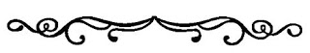
Abstract
This article was one submitted at the editor’s invitation to write about personal experiences of librarianship during COVID-19. In this article, the author reflects on several titles related to librarianship and how they pertain to notions of service as part of librarianship within the context of COVID-19.

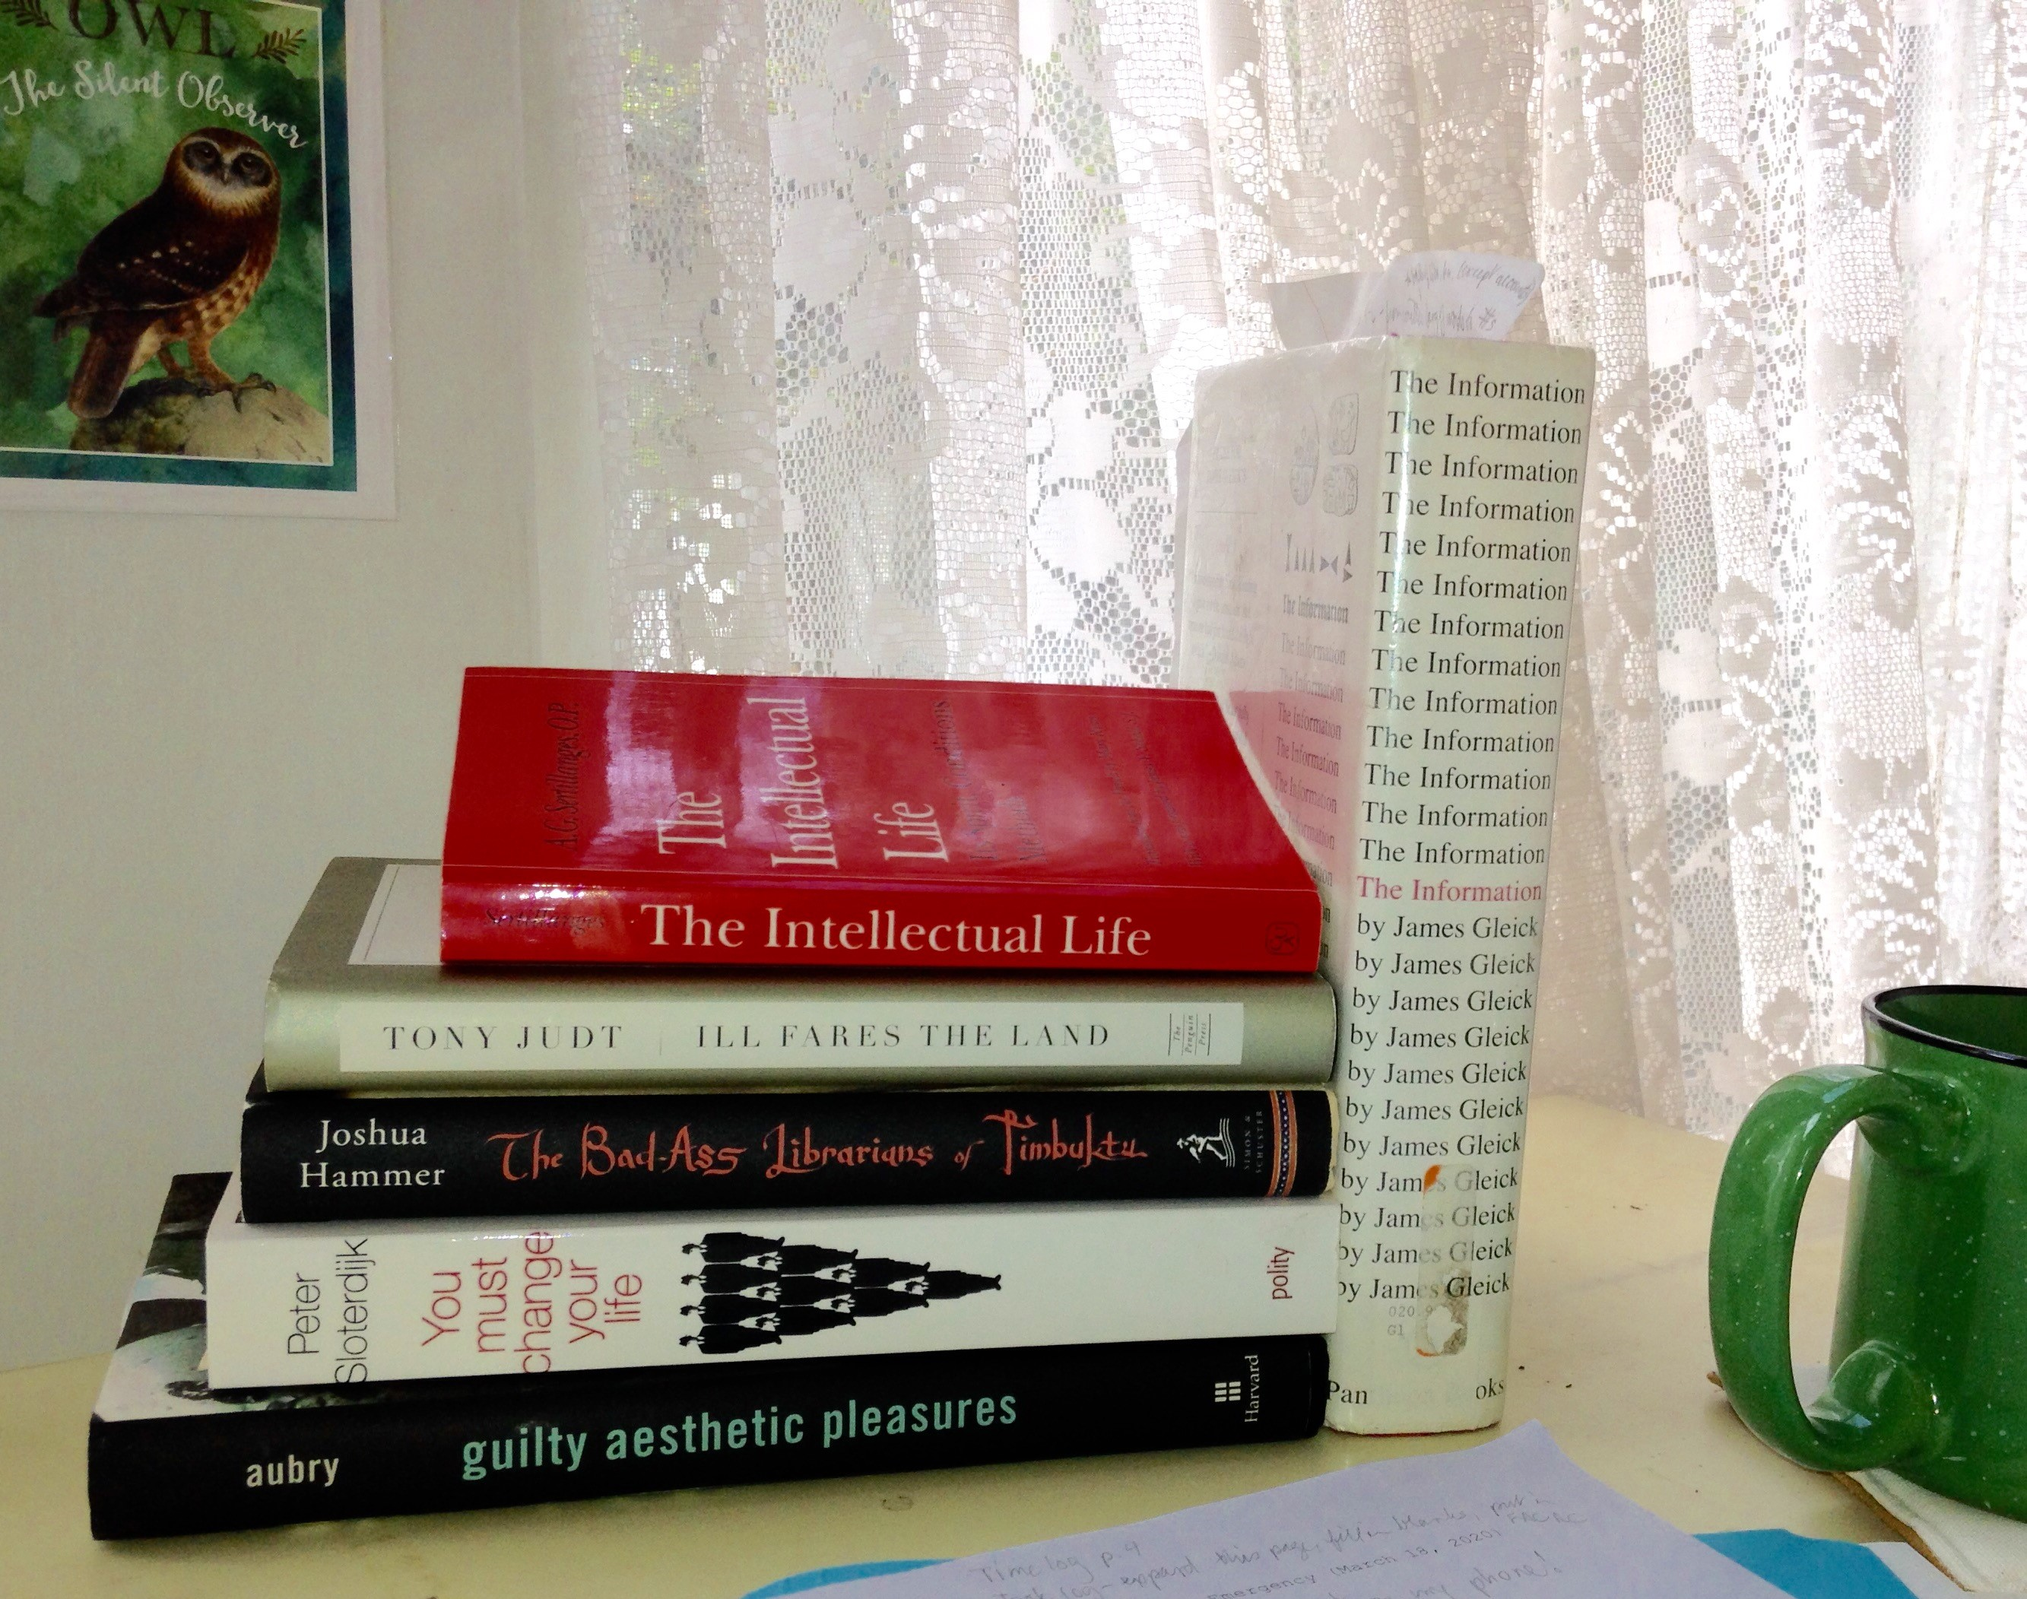

I done bought me a mask and a lot of books.
--heard on the radio

1. We provide the highest level of service to all library users through appropriate and usefully organized resources; equitable service policies; equitable access; and accurate, unbiased, and courteous responses to all requests. (American Library Association, 2008)

Although service is the first article of librarianship in the American Library Association's Code of Ethics (2008), it was a difficult one to practice while service desks and even entire buildings were closed to the public during the coronavirus outbreak of 2020. Library users could not check out books, come to study, or attend programs. In that time librarians discovered how much of "everything's online now." Despite the internet interconnectivity of our professional and educational lives, librarianship is still more than computer access and electronic content delivery; it is also detailed reference interviews and attentive, even impromptu, service. Working at home with Webex, Zoom, and wifi made some of these tasks easier and some more difficult.
How do we work from home--remotely, in isolation, with variable computer access? Our provost suggested we work on all those things we do not usually have time for during the daily routine. One of those things is to think comprehensively and deeply about how and why we do our work. Reflective journaling and communities of practice are useful but usually low on the priority list of busy librarians. Yet it is difficult to plan for the future when our present is crowded by circumstance. My approach to home-working was to continue regular routine tasks while setting some time for deep thought and slow writing. So I collected a few books, sharpened some pencils, reorganized my desk at home, and voila! One result was this essay, which will analyze and illustrate the value of reading not only professional literature but also books apparently irrelevant to the regular routine of library work. Those books on my desk offer some different ways of thinking about the nature of libraries in the service of knowledge.
Having recently become the head of a reference department, I began my reading quite practically with a basic review textbook, Crash Course in Contemporary Reference. Library educator and consultant Francisca Goldsmith (2017) emphasizes the use of electronic materials and access, though without neglecting the usefulness of print reference books, plus the necessity of knowing who the library patrons are. It was a good warm-up for the larger issues I wanted to think about.
The next book I put on my desk is also a practical handbook, though more widely applicable than the reference textbook. The Intellectual Life is written in a simple style by French Dominican priest A. G. Sertillanges (1988), and serves as a reminder that, although academic librarians are ultimately involved in the life of the mind, healthy mental work depends in part on the care of the body. "You must understand that knowledge is neither a tower nor a well, but a human habitation" (p. 103). Sertillanges' instructions might have come from a current teleworking article: plan your day wisely from morning to evening, from eating to sleeping, in order to achieve "full effort" during "the moments of plenitude" (p. 94).
Do not be ashamed to endeavor to keep well.
Sound hygiene is almost, for you, an intellectual virtue.
Look after your diet.
Work in a [posture] that gives free play to the lungs and does not compress the other organs.
Care of the body...is virtue and wisdom. (pp. 35-38)

Although this book was written a hundred years ago and is based in the teachings of medieval theologian Thomas Aquinas, its emphasis on truth, solitude, and persistence continues to be useful to intellectual workers, especially during a viral pandemic. "Study is intended to bring about the extension of our being: it must not end by making us narrow . . . The mind must stay open, must keep contact with humanity and with the world" (pp. 236--237). Sertillanges echoes Thoreau in urging his readers to "simplify your life" (p. 41). In this unpredictable situation, keeping your body calm and in order is a positive step to keeping order in your mind.
Contemporary Dutch philosopher, Peter Sloterdijk (2013) is even more emphatic in his book You Must Change Your Life. Its first chapter begins with an analysis of Rilke's poem "Archaic Torso of Apollo" (from which Sloterdijk's book's title was taken), because it is about "the source of authority" (p. 19). You Must Change Your Life is authoritative yet very slow reading even for those not used to the style of European academic philosophy. Since the literature of librarianship has almost never shown the least interest in metaphysics beyond whether to keep a print copy of Aristotle, this book is on my desk to represent the need for praxis--an ongoing theoretical analysis of authority in order to use it well.
Much more accessible than Sloterdijk's tome is The Information: A History, A Theory, A Flood, by science journalist James Gleick (2011). This book is a thorough and fascinating account of the development of communication technology and the relationship of "information" and "meaning." Both terms have been problematical for decades. Gleick does not resolve the problems, but he does analyze the causes and connections. The Information starts with African drums and the creation of writing, then moves through dictionaries and telegraphy to focus on twentieth-century information from Claude Shannon's mathematical theory to the present computerized flood. Although Gleick's accessible and well-reviewed history is not an academic monograph nor a work of LIS scholarship, it does provide an excellent context for understanding the dependence of libraries (indeed, of almost all aspects of social, economic, and professional life) on information and computers. I have used the book for teaching a basic information literacy course and a senior-level directed study; two graduating seniors taking the class last spring said they had discovered a broader sense of professional librarianship by reading it. Gleick (2011) ends with an image eerily pertinent to many librarians, of "walking the corridors, searching the shelves, rearranging them, looking for lines of meaning amid leagues of cacophony and incoherence, reading the history of the past and of the future [as] creatures of the information" (p. 426).
The Bad-Ass Librarians of Timbuktu (Hammer, 2016) is less about information and more about meaning, especially the significance of original books and manuscripts. Another popular yet historically grounded account which (not only in its title) challenges the meek stereotype of librarians and archivists, it tells a fast-moving story of how a trove of unique medieval Islamic texts was secretly relocated by their curator, Abdel Kader Haidara. Even had they been digitized, as several grant agencies urged, Haidara believed that the cultural and bibliographical value of the physical objects was worth risking difficult transportation and the potential violence of Al Qaeda.
Guilty Aesthetic Pleasures, Timothy Aubry's discussion of 20th century literary theory, also values old-fashioned books along with newer electronic apparatus. Literature professor Aubry (2018) demonstrates that various competing academic arguments "paradoxically enabled scholars to promote heightened experiences of perceptual acuity and intensity, which they implicitly treat as valuable for their own sake" (p. 3)--in other words, intellectual enjoyment of books! Aubry's book is evidence of why scholars need libraries. Knowledge itself is not only useful to, say, engineering majors who learn calculus or to nursing students who study biology, but also for sheer mental pleasure. Aristotle was right to open his Metaphysics with the declaration that humans "by nature desire to know. An indication of this is the delight we take in our senses" (p. 689). If you've forgotten the physical pleasure of browsing the stacks, choose a section to explore when your building is reopened. Class N (art--the 700s in Dewey) is good for browsing, but so are Q (science--500s), D and E (history--900s), and PR (English literature--820s). From A to Z, the library has something for everyone.
In class D you may find Tony Judt's book Ill Fares the Land. Appropriately titled for this season of coronavirus, it is on my desk for its realistic optimism amid discouraging conditions. This book is an historical analysis and critique of socioeconomic inequality in liberal political structures. In urging change, Judt (2010) writes that "if we do no more than pick up the pieces and carry on as before, we can look forward [only] to greater upheavals" (p. 2). His purpose in this short work, like the other authors in this essay, is to construct a future of economic and social justice based on sound intellectual analyses.
To end this eclectic survey of deep thought with a return to librarianship, the last book on my desk is The Politics of Theory and the Practice of Critical Librarianship. I have written elsewhere about Critical Library Studies, which as a practice has been slow to catch on outside of library and information schools but can be very useful to working librarians. This collection of essays by an international range of authors, from Ph.D. students to prominent practitioners in the field, brings fresh experience to the topic of how to think practically about the current state of librarianship and how to direct it toward more equitable, just, and effective service.
During the pandemic, libraries have performed with steady devotion to their ideals of service, information provision, and equitable access. Canadian liaison librarian Lisa Sloniowski declares that "academic reference librarians must engage the concepts of critical information literacy and social justice...and fight for intellectual freedom and freedom of expression" (quoted in Nicholson & Seale, 2018, p. 60). Whether through the pages of a book, the electronic stream of the internet, or drive-thru service, corona'd librarians must use all our resources in the present for the unforeseeable future.
References
American Library Association. (2008). Code of ethics. www.ala.org/tools/ethics
Aristotle. (1941). Metaphysics (W.D. Ross, Trans.). In Richard McKeon (Ed.), The Basic Works of Aristotle. Random House.
Aubry, T. (2018). Guilty aesthetic pleasures. Harvard. https://books.google.com/books/about/Guilty_Aesthetic_Pleasures.html?id=VBtmDwAAQBAJ
Gleick, J. (2011). The information: A history, a theory, a flood. Pantheon. https://books.google.com/books/about/The_Information.html?id=7ztdygAACAAJ
Goldsmith, F. (2017). Crash course in contemporary reference. Libraries Unlimited.
Hammer, J. (2016). The bad-ass librarians of Timbuktu. Simon and Schuster.
https://www.google.com/books/edition/The_Bad_Ass_Librarians_of_Timbuktu/zXn0CwAAQBAJ
Judt, T. (2010). Ill fares the land. Penguin Press. https://www.google.com/books/edition/Ill_Fares_the_Land/690rDmglflYC
Nicholson, K. P., & Seale, M. (Eds.). (2018). The politics of theory and the practice of critical
librarianship. Library Juice Press.
Sertillages, A.G. (1988). The intellectual life. (M. Ryan, Trans.). Catholic University
Press of America. (Original work published 1902).
Sloterdijk, P. (2013). You must change your life (W. Hoban, Trans.). Polity Press. https://www.google.com/books/edition/You_Must_Change_Your_Life/a_DcBAAAQBAJ

