President's Column
Change and the Ability to Cope with Change: When to Accept, When to Reject?
Karen Niemla, University of Louisiana at Monroe

During the 2013 LOUIS Users' Conference (LUC) in Port Allen, Louisiana, I attended several sessions about SirsiDynix's new software products. SirsiDynix is thus far the LOUIS consortium's library automation software company of choice, and I knew that they had new products on the horizon which I was excited to know more about. At the start of one of these sessions, the SirsiDynix representative smiled and said that there were going to be a lot of new changes coming. "And we all know how librarians love change!" We all laughed. It's healthy that we can all laugh at ourselves, but it's also worth some reflection. Librarians evidently have a reputation for being difficult customers, and we know it. Is that bad? Or is that good?
Despite the efforts of many librarians to break the mold and be more progressive and modern, librarians do seem to have a stereotyped public image, as we all know: staid, strict women with glasses. The damaging part of the stereotype is the component which characterizes librarians as people who are opposed to change, and that the profession itself is a relic of the past. Although the physical stereotype of librarians does seem to be true more often than one might think, the ideological stereotype is one which we all should overtly reject. Unfortunately, even we know that it is still sometimes true as well. There is a tension between trying new things and losing time and labor doing so. Was Second Life ever a useful place to develop virtual libraries and new patron communities? I believe the answer is "no," but not simply because I wasn’t used to it; I didn't like it because I couldn't imagine a practical use for it. How did I make that determination? When is it appropriate or not appropriate to reject a new software, updated version, or platform? It’s unsurprisingly complex and dependent on particular circumstances.
We can start with the ubiquitous software all of us have to use at some point, whether at home or at work or elsewhere: the Windows operating system. Microsoft's latest version, Windows 8, is radically different from previous versions of Windows, and has not been greeted with much enthusiasm. Is the poor reception due to consumers' rejection of the unfamiliar, or because it is legitimately inferior? My sister and her husband have had a Windows 8 laptop (without a touch-screen) for about a year now, and she says that she hates using it "because of Windows 8." I didn't know how bad it was until I experienced the frustration for myself.
Windows 8 has been difficult for Microsoft to sell, and its market share (a percentage of all desktop computers running any OS) is still low, only 10%. It’s well behind the 13 year-old Windows XP, which remains an embedded favorite at 30% despite the looming discontinuation of its security updates in only a few months, while Windows 7 has almost half of the market (Hernandez, 2014, p.20). I suspect that is partly due to business users who do not want the complications of re-teaching all their personnel how to use the pretty colored blocks that keep covering their serious work all the time. In his review for the Journal of Property Management, Todd Clarke (2013) writes, "In order to get Windows 8 to function efficiently, it requires me to select 'Desktop mode,' which is a couple of clicks or swipes to locate. Essentially, Microsoft has just added another layer between me and my work in order to reach the function I need."
He concludes that 8 is not worth buying and complains also that fingerprints on touch screens are distracting on a desktop machine. He's not the only person to notice. Here at ULM the Windows OS of choice is 7, and one lab technician I spoke to about Windows noted that bringing touch screens into a library computer lab would literally be a mess, with dirty fingerprints all over the screens, all day, spreading germs and gunk. The fact that Windows 8 is optimized for touch screens is very problematic in that not everyone has them or wants them. Windows is supposed to be the best desktop OS, yet it can’t reach that status when using Windows 8 with a mouse alone is awkward. It's almost like Microsoft were so fixated on catching up with Apple and Google that they forgot how to do the one thing they were good at.
It is difficult to carry out tasks which were once simple because Windows 8 has a personality disorder, trying to behave like both a desktop environment and a touch-screen tablet. It has the usual desktop interface, with its "Start" button removed, the menu button which used to do everything. The replacement is an extra interface, "Modern," which is suited for touch screens, and each time you open the "Start" menu it changes to Modern (even if you don't have a touch screen). Everyone, from the new users to seasoned power users to business productivity users, will need to learn Windows all over again, after having known it since 1995, when Microsoft was actively teaching everyone how to use the "Start" button in their advertising.
All applications in the touch interface open and run in full screen mode, and whenever you open the "Start" menu, it covers up all the windows you had open and everything you were doing. This is fundamentally silly. From the time Windows was created, one of the best advantages it (and the Macintosh) had over Microsoft DOS (Disk Operating System) was that users could multitask and run several programs at one time, placing each program in its own "window," hence the namesake of Microsoft Windows. This means that Windows 8 is functionally more like DOS, in a way. Of course, Apple too had already been calling these design elements "windows" by 1984, but they didn't put it in the title of the Mac OS, nor did they try to call their mobile-based OS by the same name as the desktop OS; They had no logical reason to do that, since they are different programs for different purposes. Full screen apps are even stranger considering that average desktop monitor resolutions are higher than ever. Using full screen applications all the time makes poor use of the ample real estate on the screen.
I at least know some useful Windows keyboard commands to help me get around, such as pressing "Alt" and "F4" together to close a program, or "Alt" and "Tab” to switch between programs, which are especially useful when Windows 8 has few to no visible indicators which might signal users on how to do those tasks otherwise. That's a big problem for average (or below average) users. The silver lining for me is that I had to learn and memorize some new key commands that I didn't know before: hitting the Window Key and "D" shows the desktop, and pressing "Ctrl," "Shift," and "Esc" together brings up the task manager. These work in previous versions of Windows, and are happily hand, but In Windows 8, they are critical, so much so that J. Carlton Collings (2012) included an entire list of "essential" keyboard commands in a review for 8 in the Journal of Accountancy. Collings concluded "Given the reliance on Windows-powered computers and applications in the accounting profession, CPAs and their organizations have little choice but to look into Windows 8." This is both the best and the worst case one can make about whether or not one should buy Windows in general: because most of our applications run on Windows, we "have little choice but" to go ahead and buy it.
That leaves the other versions of Windows, but the poor performance of 8 has caused Windows 7 to remain popular and expensive even though it's not the newest version. Unwilling to spend $100 on 7, last year I opted to buy an upgrade version of its predecessor, Windows Vista, for around $30, to upgrade from XP. Vista is not as stable or as fast as 7, but it is cheaper and more likable than 8, which is enough of a bargain for me. I'm happy with Vista.
Five years ago I wouldn't have believed that I would ever say that. Upon its release in 2006, Vista was as reviled as Windows 8 is now, perhaps even more so, and it damaged Microsoft as frustrated users left for other platforms or clung to Windows XP with white knuckles. It also took too long to develop, allowing the public to fall deeper in love with XP. Steve Ballmer, Microsoft's CEO during much of the 2000s, has admitted recently that one of the biggest regrets of his reign was allowing Vista's development to go on too long (Reisinger, 2013, p.10). During that time, competitors got the leverage they needed.
The most hated of Vista's new features was the UAC (User Access Control), which prompts you for permission every time you try to do something like install a program or change settings. Hardware compatibility and driver issues plagued users, such as my brother, who had to stop using a printer and scanner after he bought a Vista PC because the printer manufacturer did not have any new drivers yet. Consumers rejected Vista. As Don Reisinger (2013) summed it up in eWeek magazine, "Even PC hardware vendors, the essential factor in Microsoft's operating system sales success, offered 'downgrades' to XP to sell more devices. It was bad, bad, bad."

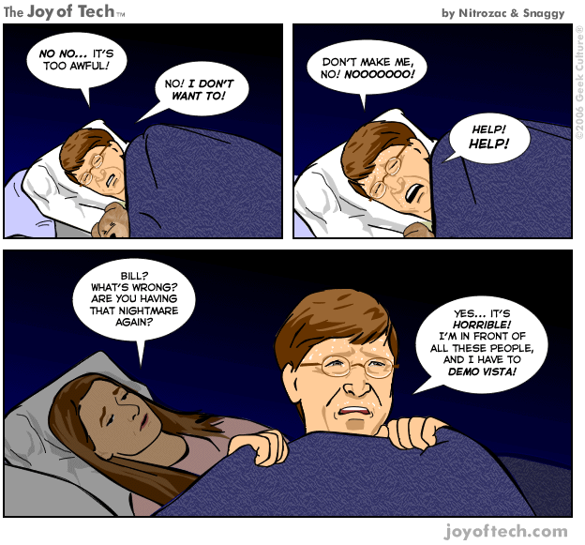
However, now that I have seen Windows 8, I feel like I owe Windows Vista an apology: "I'm sorry. I didn't know how bad things could really get! You're not so bad after all!" There were interface changes in Vista that users needed to adjust to, and after some time and updates, the driver issues with Vista greatly improved. Currently I use 7 on the computers at my library and it's similar to Vista apart from better general performance, so it does seem unfair that 7 is so loved and Vista so hated. I suppose it is possible that Windows 8 could become more palatable over time in the same way. We've yet to see what Windows 9 will be like.
Microsoft's missteps with Vista and 8 might indicate that it was a mistake to change their product at all. Paradoxically, that could not have worked either. Avoiding change and failing to innovate and try new ideas is risky in its own way. In the mid-00s, they had to do something, just anything, to keep up with the changes happening around them. It was an issue for other computer companies, including one of Microsoft's longtime bedfellows, Dell.
In 2002 the internet comic Joy of Tech published a cartoon in which Michael Dell (the founder of the Dell computer company) has a nightmare about Steve Jobs introducing an impossibly stupendous new Macintosh on stage in a packed theater. A sweaty and distraught Dell awakens in a cold sweat, relieved that it was only a dream, but bloody text at the end of the comic adds, "OR WAS IT?" The comic is funnier and stranger twelve years later than it was back then, because apart from the jetpack part, the nightmare really came true.
When Steve Jobs returned to Apple in 1997, Michael Dell publicly commented that Jobs should close Apple down "and give the money back to the shareholders." Jobs was offended by the comment, and told Dell so via email. Eventually Jobs took Apple into the custom PC business, and made Michael Dell into a symbolic personal enemy for Apple employees to defeat (Isaacson, 2011, p. 334). So far, they have been successful, due to many factors, but mostly to Apple creation of a new industry in which they could excel.
Apple could never get ahead of the Windows desktop computers in the PC market. The Macintosh, although often better in quality, would not be able to match the price and ubiquity of the competitors. In the early 2000s, there were other avenues to pursue other than the PC, however. When Steve Jobs introduced the iPod in October 2001 he did so in one of the smaller presentation rooms of Apple's headquarters, and it was not treated as a major product debut. Not everyone knew what to think of it, and no one knew right away that it was going change how consumers interacted with and bought computers (Edwards, 2011). When the iPod and iTunes software became available to Windows users a year later, millions of wallets which had previously been closed to Apple were now opened broadly towards them.
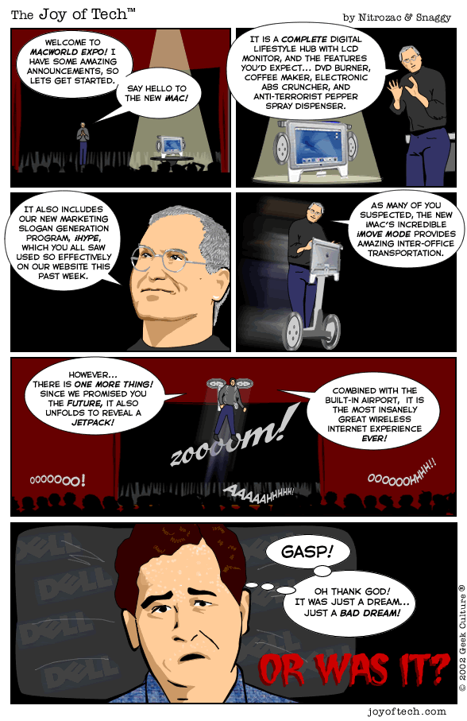

Some people remained derisive of Apple, and still pointed to desktop market share percentages as proof of the company's impotence, saying that it had become focused on mere consumer electronics. Over time that rubric ceased to matter, and in 2007 the company changed its name from "Apple Computer" to "Apple Inc." Steve Jobs pointed out Apple's product line: "The Mac, iPod, Apple TV, and iPhone. Only one of those is a computer. So we're changing the name" (Macworld, 2007, p. 24). Literally they were no longer a computer company. During his last keynote speech in 2011, Jobs unofficially brought the era of the personal computer to an end (at least at Apple), making the Macintosh equal to the iPad and iPhone. In some way this gesture legitimized the transformation which Apple had undergone in his final decade, saying that what Apple was doing did not make it a lesser company because it didn't have high market share in PCs, but rather, that Apple was a greater company because it could do so much more than that.
Jobs' predicted vision of the industry is arguably our reality, and thus cartoon (and probably real-life) Michael Dell's nightmare became reality as well. Personal computer sales are seemingly getting lower and lower, causing Dell's stock value to taper by one quarter in recent years (Tsukayama, 2013, p. A10). I imagine this was not helped by consumers' distaste for various Windows products, which are linked inextricably with PCs. Last year Mr. Dell did the opposite of what most famous technology companies do: Dell bought out shareholders and took the company back to private, rather than publicly traded status (Tsukayama, 2013, p. A10).
Just last fall The Washington Post reported on Dell's plight: "the company has lost its footing as competitors emerged with cheaper desktop and laptop computers and its core audience migrated to hand-held devices such as tablets... Michael Dell will face a staggering set of challenges in rebuilding the Round Rock, Tex.-based company. The company's profit dropped more than 70 percent during its most recent fiscal second quarter compared with the same period the previous year. It was once a market leader, but it now captures just about 12 percent of worldwide PC sales" (Tsukayama, 2013, p. A10).
I am sad to hear that, and it makes me feel a bit old. I remember that in the early 2000s, Dell was very popular, and everyone I knew was either buying computers from Dell or wishing they could. Giving consumers options and choices in how much or how little to include with the computer was, at the time, exciting and new. You could "build" your own computer (but not literally). The first computer I ever bought for myself was a refurbished Dell Dimension, which I used for over six years and still keep fondly in a closet following its retirement. Most of the computers at my current library have been serviceable Dell PCs as well. The build quality for Dell products remains generally good if you want a PC, but that is the issue: "if you want a PC."
As librarians, the goings-on of the computer technology world are most relevant to us in that they dictate what is available to us as institutional consumers, as well as the expectations of our patrons. Yet we too form a market of our own, and what we accept and reject in the library hardware/software niche forms what our patrons' experiences will be like, and thus, it creates the present and future of all libraries. Considering this, it's neither appropriate to excitedly embrace all new technology, nor is it appropriate to skeptically reject it all.
For example, look at EDS. I love EBSCO Discovery Service. I actually do believe that it is better than EBSCOhost, since it has many of the same features but with more functionality (in fact, I'm still not 100% sure why these need to be separate products). EDS does not force users to deal with the confusing and tedious "choose databases" list, which I believe is a great improvement. I am unofficially the ULM Library "webmaster" and when we redesigned our webpages earlier in 2013 I set up a search box for it. A single Google-like search can be the equivalent of opening a stuffed storage closet and everything just falls out on top of you. Yet in EDS this is manageable, almost pleasurable, with so many different ways to sort everything into smaller and smaller piles.
However, I don't love EDS enough to actually make it the one and only search box on the library home page. EBSCO Discovery Service doesn't seem to do absolutely everything that a true catalog can do, even though EBSCO markets it as such. Other Louisiana libraries have been able to trust EDS alone on their home pages, which is fine, but I personally do not think it is enough. The litmus test I use to prove this is to look for Time magazine: unless I'm doing something wrong, it is still extremely difficult to ask EDS for a specific title containing common words. The SirsiDynix e-Library OPAC can handle that search much better, since you have the option to tell it how to match the search terms and where.
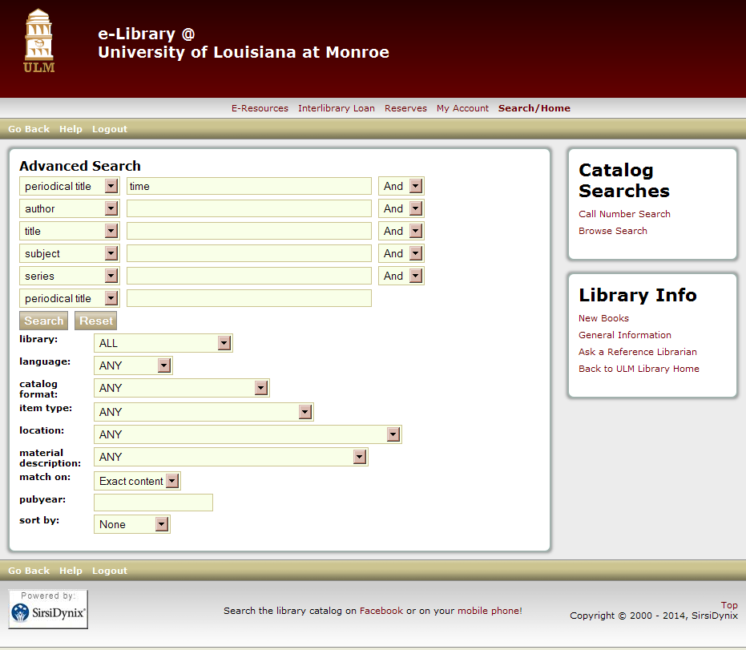
If you are looking for a specific book or journal (or etcetera) title, the OPAC always seems to outperform EDS. Thus they both share space on our library home page.
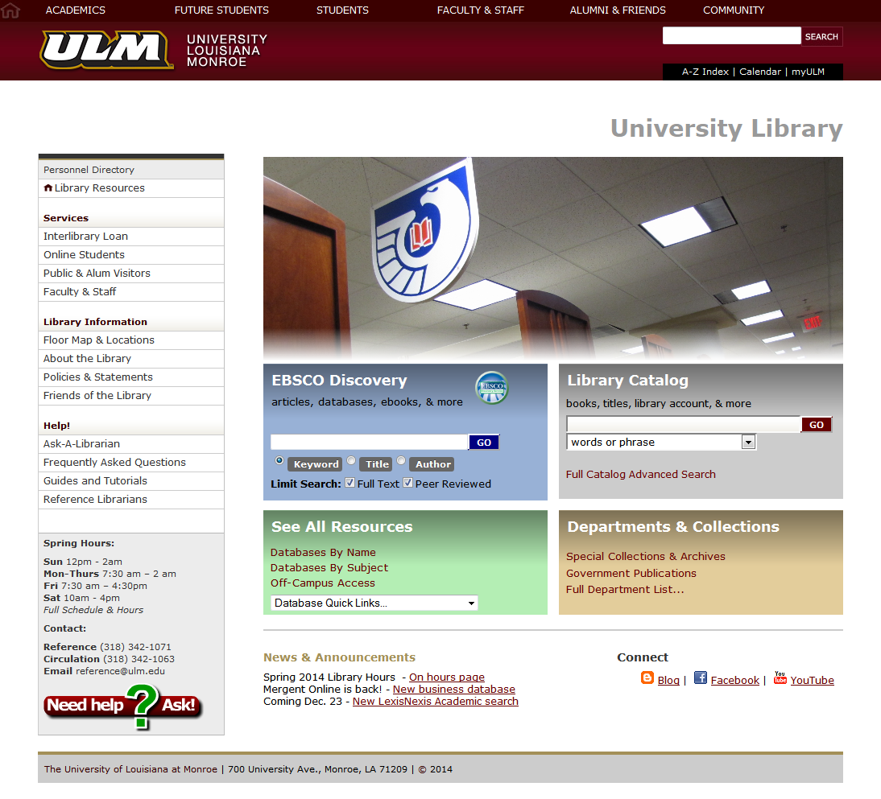

Does that mean that I love e-Library too? No it doesn't. I do not like e-Library. For a long time I have been convinced that the e-Library interface actually causes users to turn away when they encounter it, based on my own experiences with patrons and alone. Unless you're looking for a specific title, or want to search the print collection alone, e-Library is not especially helpful, despite its strengths in other aspects. Doing a general keyword search in an e-Library catalog usually brings back either nothing or a long list of results which is difficult to sort through. If you are searching it for a certain subject, you need to know the exact magic words to enter, because a subject keyword search may or may not actually work. If you can't type or spell your terms perfectly, e-Library cannot help you. If you dare use the "back" button in your browser, it stops working and forces you to start over.
It feels like a lumbering unmaneuverable dinosaur, as if it was coded in the Stone Age (or the 1990s). It's an embarrassment to have to show it to patrons, who are used to fully functional modern websites like Amazon.com. The issues I have with e-Library (and any other lackluster library product) is less about what it is, and more about what it means: the mechanisms by which our patrons reach our collections are not as good as they could be, and that will very likely deter them from using the library at all, whether it be from failed searches, or from being put off by a difficult or ugly interface. It just leaves everyone with the wrong impression.
Although still necessary, e-Library needs improvement. But in early 2013 I heard during the Louisiana Library Association conference that SirsiDynix had no plans to update it. I was initially disappointed to hear that, but later I found out why. In the spring of 2013, I attended the COSUGI (Customers of SirsiDynix Usergroup Inc.) conference in Salt Lake City Utah, where SirsiDynix revealed its new suite of library automation software, BLUEcloud, including its OPAC component, BLUEcloud PAC (note that the "O" is no longer necessary). Naturally, I was delighted to hear the news, and wanted to see them do away with e-Library as soon as possible.
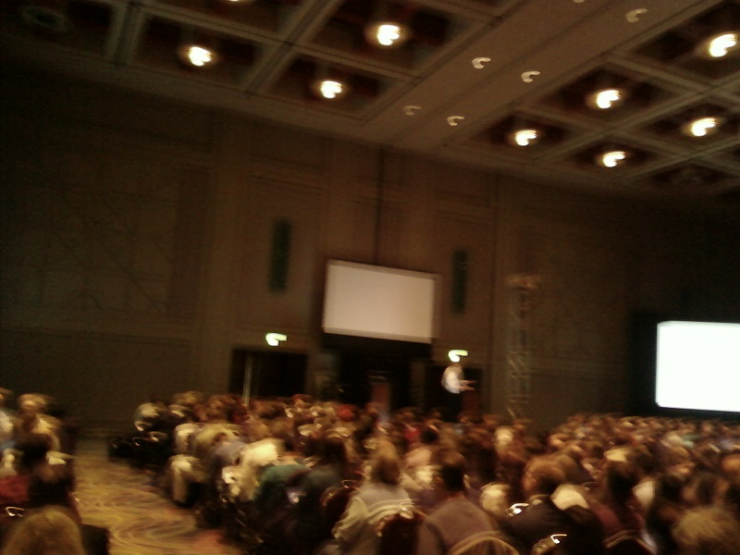
During a question and answer session I asked what was going to happen to e-Library, eager to know how soon it could be destroyed. The executives answering me thought I meant that I was concerned about e-Library. I had to explain that I meant that I wanted it to be discontinued. Evidently, it was uncommon to be enthusiastic about changes. There was a palpable bitterness amongst the librarian attendees which I couldn’t explain. Many librarians seemed jaded and had difficult, judgmental questions to ask about the new software rollout. I did not see anyone being rude, of course, so I assumed they all knew something I didn't.
I asked someone about it and later learned that the skepticism stems from the 2005 merger of two companies, Sirsi and Dynix, which created SirsiDynix (Deseret Morning News, 2005). Apparently, the respective software products of Sirsi and Dynix were not treated equally, and loyal customers were very unhappy with SirsiDynix's lack of support for the products they had chosen in the first place. Thus SirsiDynix still supports both the Horizon and Symphony library platforms (even though it does complicate the company’s identity to do so).
Yet I, being a reference librarian rather than a cataloging librarian (the most abundant librarian type at COSUGI), did not have this history on my mind. I talked to one of the many (many, many) SirsiDynix representatives at the conference and asked him why SirsiDynix wasn't overtly ending support for e-Library and replacing it with BLUEcloud PAC right away. I bluntly pointed out that e-Library is garbage that no one should have to use it a moment longer. The SirsiDynix man happily agreed that e-Library was no good. I asked "Why isn't SirsiDynix being bolder? Steve Jobs wouldn't have kept e-Library around."
Indeed, that was Jobs' style. In the early 2000s, Apple released Mac OS X (ten). It was a departure from previous versions of the Mac OS, and it shared many similarities with the NeXTSTEP OS from NeXT, the computer company Jobs had sold to Apple before his return. At one of the Apple keynotes, Jobs held a mock funeral where the previous OS 9 was literally laid to rest, complete with a black casket onstage. Not everyone was willing to let go, however. Some users still preferred the more traditional Macintosh OS, but ultimately he prevailed. This was likely due to the quality of the product: the Mac OS X series is still today a highly respected and innovative desktop environment, even though it has miniscule market share.
I told the SirsiDynix representative, "If Steve Jobs were here, he would have said, 'e-Library is done, BLUEcloud is here, and if you don't like it, too bad!'" He just laughed and said something like, "Librarians are different! You can't do that with librarians!" I was under the impression that, again, he knew more about this than I did, and it was silly to imagine dealing with librarian customers in a Jobsian way. Evidently that could not work. But why can't it work, though? Why can't we have superior products sooner? JSTOR is also undergoing a re-design, and it's been in beta for months and months. I
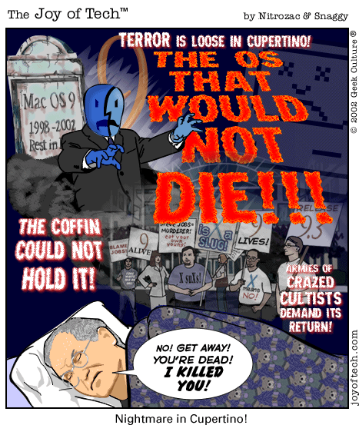
think it's superb; they've apparently copied EBSCO's products, and put a column of search limiters on the left side of the page which allows you to sort results quickly. It's not original, but I can't hold it against them. As the old expression goes, "Imitation is the sincerest form of flattery." I look forward to being able to use JSTOR more effectively after its search results contain less junk. Yet again, we're being made to wait for it. JSTOR needs to be fixed now; it's a great database and deserves to be used more. SirsiDynix's e-Library is terrible and needs to be dumped and replaced now. I want these improvements now, so that our patrons can have better products.
"Be careful what you wish for," as they say. JSTOR's search has been in beta form for months. SirsiDynix's BLUEcloud PAC is not even available in beta yet, almost a year after the announcement (although it will be soon). The last time LexisNexis Academic changed its interface some years ago, it was announced early, and we were even given the opportunity to switch over early if we wanted to. But in December 2013 my desire for celerity was fulfilled, and it wasn't as pleasant as I had assumed it would be.
During LUC 2013 there was a session on LexisNexis Academic, and the LexisNexis representative showed us features in the database as it already was, while only mentioning that a new interface was in the works, with a few images. They did not have a working live demo ready for the conference, which was in October. I didn't realize it then, but they sought to release the new interface in only two months. It was an unbelievably rushed rollout. In early December 2013 I went to a webinar about LexisNexis Academic's new interface, and found myself getting upset after learning how many components weren't even completed yet. About five parts were not yet finished for the webinar demo, including the ability to search for individual people, which is unique to LexisNexis Academic. I also got the impression that other librarians were upset too; the representative seemed stressed and rushed. Yet with a release schedule as narrow as three weeks, how else could we be expected to react? The new interface was coming out on December 23rd, giving librarians and patrons only a few weeks to prepare, and without being able to try it out. The beta version could only be accessed if you attended a webinar and specifically asked to have the beta link (and again, the webinars didn't start until December).
On top of this, the emailed beta link came with these orders, complete with e-yelling: “PLEASE do not post this information to any websites or listserv. PLEASE do not share this information with students. This is a BETA product. We are only granting access to individuals that attend one of our webinars. We appreciate your cooperation on this matter.” But why wouldn't we want to show the new database to patrons and other librarians? We need to do that. I'm a big fan of LexisNexis Academic and it has been my personal favorite database for 12 years, and so I expect better from them. They very obviously rushed the interface to get it out at the end of the year, and didn't even have a finished product to show anyone before that. They said that they wanted customer feedback, but with such a short amount of time before release and so much secrecy, it doesn't feel like they wanted to listen to anyone at all. It's slightly insulting. I know what it's like to sometimes procrastinate and rush towards looming deadlines, but LexisNexis is supposed to be better than I am.
The new Academic interface itself is not bad, now that the missing search components have been completed and added (like they should have been in the first place!). The old blue tabs on the right of the screen that used to allow you to choose a type of material to search have been condensed into a "Search By Content Type" menu which appears to work well so far.
However, after doing an initial search and reaching a results list, the interface goes back to looking exactly how it did before, which is not necessarily a compliment, because there is so much to sift through. LexisNexis is older than the World Wide Web, dating back to the late 1970s. Yet these deep resources often remain untapped because they’re hard to reach. Maybe I am an EBSCO addict, but do often wish LexisNexis Academic were more like it. Overall the new interface works, but the customer service experience leading up to it was irksome.
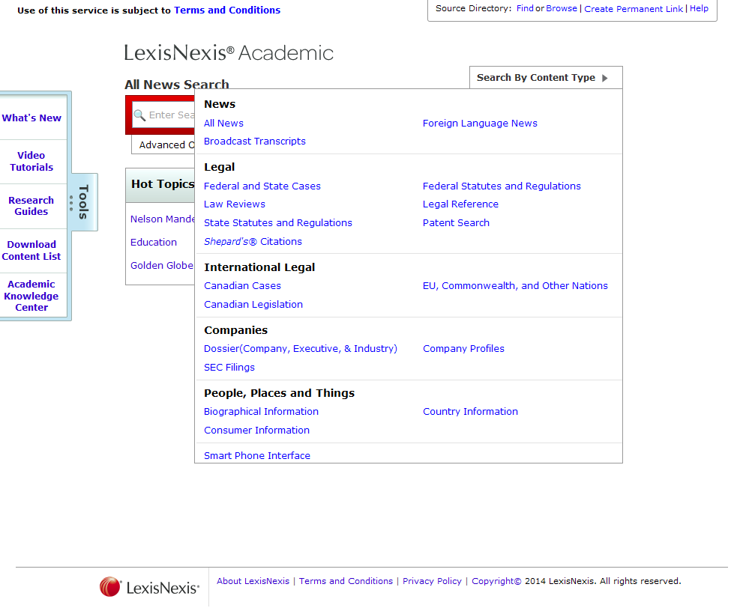
Now that I've had a taste of inept corporate haste, I better understand SirsiDynix's skeptics who may want to approach BLUEcloud PAC with caution. However, I still maintain that e-Library needs to be cast away sooner rather than later, and according to some SirsiDynix emails I've received in recent days, the time has come: librarians will soon be able to participate beta testing for the first version of BLUEcloud PAC! It has been almost a year since the BLUEcloud family was introduced, and although I wanted to see it arrive sooner, I do hope that the extra time and effort SirsiDynix put into it will result in a good product.
I enthusiastically encourage all of you to take the opportunity to try BLUEcloud PAC for your library if you are able to do so, and let's be fair about it as well. We should always get upset when products we have paid money for do not reach our expectations. It is meet and right so to do! However, we should not reject BLUEcloud PAC and continue using outdated tools unless there are some serious issues that make it a poor product.
As I've learned from LexisNexis, moving too quickly can result in an unfinished product and frustration for everyone. But on the other hand, can librarians afford to wait (especially with fossils like e-Library still in use)? As I've observed, time movies quickly in the IT industry. Windows Vista took too long to finish and the result was so severe that Steve Ballmer calls the delay the biggest mistake of his career. In only five years' time, Dell computers lost a significant chunk of its business. It is probably no different for us. We need to move forward, yet we are entitled to gripe as we go.

References

Apple drops computer from its name. (Brief article). (2007). Macworld, (3). 24.

Clarke, T. (2013). Windows 8: Worth the Upgrade?. Journal Of Property Management, 78(2), 49.

Collings, J. (2012). Windows 8: Jump or Wait?. Journal Of Accountancy, 214(5), 40-47.

Edwards, Benj. (2011). The birth of the iPod. Macworld. Retrieved from http://www.macworld.com/article/1163181/the_birth_of_the_ipod.html

Hernandez, P. (2014). Windows 8 Surpasses 10 Percent Market Share. Eweek, 20.

Isaacson, Walter. (2011). Steve Jobs. New York: Simon & Schuster.

(June 22, 2005 Wednesday ). Sirsi, Dynix to merge info tech operations. Deseret Morning News (Salt Lake City).

Reisinger, D. (2013). Steve Ballmer's 10 Biggest Mistakes as Microsoft CEO. Eweek, 10.

Tsukayama, Hayley. (September 13, 2013 Friday ). A challenging reboot for Dell. The Washington Post.

CEO Nightmare Cartoons (used with permission)

Nitrozac, & Snaggy. (2002). Number 278. The Joy of Tech. Retrieved from http://www.geekculture.com/joyoftech/joyarchives/001_300/278.html

Nitrozac, & Snaggy. (2002). Number 333. The Joy of Tech. Retrieved from http://www.geekculture.com/joyoftech/joyarchives/301_999/333.html

Nitrozac, & Snaggy. (2006). Number 856. The Joy of Tech. Retrieved from http://www.geekculture.com/joyoftech/joyarchives/301_999/856.html

(Permissions available upon request)

